Department of Computing

Syed Muhammad Dawoud Sheraz Ali-111417

BESE-5B

**Lab 10: City Search NoSQL**

**Date: May 10th, 2017**

**SE312: Software Construction**

**Instructor: Fahad Ahmed Satti**

**Lab Engineer: Ms. Maryam Sajjad**

**GitHub:** <https://github.com/SyedDawoud/University/tree/master/Software%20Construction/Labs>

# Introduction

This lab is an extension of previous labs on City Search. This particular lab is about performing the same operations we did in City Search, but now we have to use Document-Oriented NoSQL database.

# Approach & Analysis

The basic approach followed is to store the data inside database. First task is to model the Country, City and Location classes. When these classes have been created, we use the sessions to store the data in the database created accordingly. When this is done, the next step is to implement functionality. For getting the longitude and latitude, the simple step is to take city name and query the database. Next task is to find the neighboring cities, given the city name or longitude and latitude. This has been done using the Great Circle Distance formula, which is:

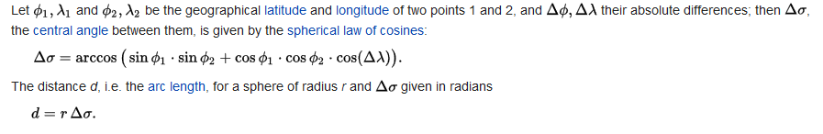

Source: <https://en.wikipedia.org/wiki/Great-circle_distance>

# Running the Code

This application requires the installation of the NoSQL database like MongoDB. It must be setup before code can be used.